The Floyd-Warshall algorithm is a dynamic programming algorithm used to discover the shortest paths in a weighted graph, which includes negative weight cycles. The algorithm works with the aid of computing the shortest direction between every pair of vertices within the graph, the usage of a matrix of intermediate vertices to keep music of the exceptional-recognized route thus far.

But before we get started, let us briefly understand what Dynamic Programming is.

**Understanding Dynamic Programming**

Dynamic programming is a technique used in computer science and mathematics to remedy complicated troubles with the aid of breaking them down into smaller subproblems and solving each subproblem as simple as soon as. It is a technique of optimization that can be used to locate the pleasant technique to a hassle with the aid of utilizing the solutions to its subproblems.

The key idea behind dynamic programming is to keep the solutions to the subproblems in memory, so they can be reused later whilst solving larger problems. This reduces the time and area complexity of the set of rules and lets it resolve tons larger and extra complex issues than a brute force approach might.

There are two important styles of dynamic programming:

1. Memoization
2. Tabulation

Memoization involves storing the outcomes of every subproblem in a cache, in order that they may be reused later. Tabulation includes building a desk of answers to subproblems in a bottom-up manner, beginning with the smallest subproblems and working as much as the larger ones. Dynamic programming is utilized in an extensive range of packages, including optimization troubles, computational geometry, gadget studying, and natural language processing.

Some well-known examples of problems that may be solved by the usage of dynamic programming consist of the Fibonacci collection, the Knapsack trouble, and the shortest path problem.

**History of Floyd-Warshall algorithm:**

The Floyd-Warshall set of rules was advanced independently via Robert Floyd and Stephen Warshall in 1962. Robert Floyd turned into a mathematician and computer scientist at IBM's Thomas J. Watson Research Center, whilst Stephen Warshall became a computer scientist at the University of California, Berkeley. The algorithm was originally developed for use inside the field of operations research, where it turned into used to solve the all-pairs shortest direction problem in directed graphs with tremendous or negative side weights. The problem become of outstanding hobby in operations research, as it has many applications in transportation, conversation, and logistics.

Floyd first presented the set of rules in a technical record titled "**Algorithm 97: Shortest Path" in 1962**. Warshall independently discovered the set of rules quickly afterwards and posted it in his personal technical document, "**A Theorem on Boolean Matrices**". The algorithm has on account that emerged as a cornerstone of pc technology and is broadly used in lots of regions of studies and enterprise. Its capability to correctly find the shortest paths between all pairs of vertices in a graph, including those with terrible side weights, makes it a treasured tool for solving an extensive range of optimization problems.

**Working of Floyd-Warshall Algorithm:**

**The set of rules works as follows:**

1. Initialize a distance matrix D wherein D[i][j] represents the shortest distance between vertex i and vertex j.
2. Set the diagonal entries of the matrix to 0, and all other entries to infinity.
3. For every area (u,v) inside the graph, replace the gap matrix to mirror the weight of the brink: D[u][v] = weight(u,v).
4. For every vertex okay in the graph, bear in mind all pairs of vertices (i,j) and check if the path from i to j through k is shorter than the current best path. If it is, update the gap matrix: D[i][j] = min(D[i][j], D[i][k] D[k][j]).
5. After all iterations, the matrix D will contain the shortest course distances between all pairs of vertices.

**Example:**

Floyd-Warshall is an algorithm used to locate the shortest course between all pairs of vertices in a weighted graph. It works by means of keeping a matrix of distances between each pair of vertices and updating this matrix iteratively till the shortest paths are discovered.

**Let's see at an example to illustrate how the Floyd-Warshall algorithm works:**

**Consider the following weighted graph:**

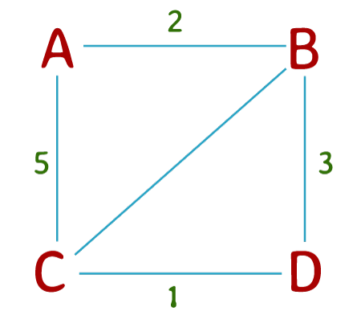

**Figure:** A Weighted Graph

In this graph, the vertices are represented by letters (A, B, C, D), and the numbers on the edges represent the weights of those edges.

To follow the Floyd-Warshall algorithm to this graph, we start by way of initializing a matrix of distances among every pair of vertices. If two vertices are immediately related by using a side, their distance is the load of that edge. If there may be no direct edge among vertices, their distance is infinite.

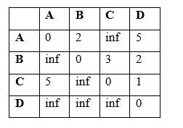

In the first iteration of the set of rules, we keep in mind the possibility of the usage of vertex 1 (A) as an intermediate vertex in paths among all pairs of vertices. If the space from vertex 1 to vertex 2 plus the space from vertex 2 to vertex three is much less than the present-day distance from vertex 1 to vertex three, then we replace the matrix with this new distance. We try this for each possible pair of vertices.

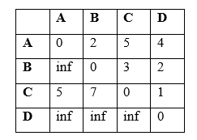

In the second iteration, we recollect the possibility to use of vertex 2 (B) as an intermediate vertex in paths among all pairs of vertices. We replace the matrix in the same manner as earlier before.

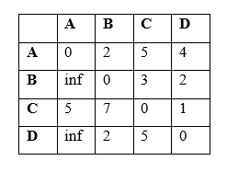

In the third iteration, we consider the possibility of using vertex 3 (C) as an intermediate vertex in paths between all pairs of vertices.

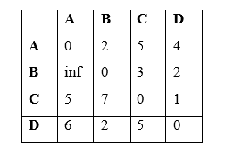

Finally, in the fourth and final iteration, we consider the possibility of using vertex 4 (D) as an intermediate vertex in paths between all pairs of vertices.

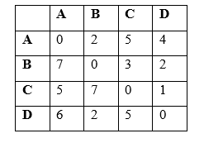

After the fourth iteration, we have got the shortest path between every pair of vertices in the graph. For example, the shortest path from vertex A to vertex D is 4, which is the value in the matrix at row A and column D.

After the fourth iteration, we have got the shortest path between every pair of vertices in the graph. For example, the shortest path from vertex A to vertex D is 4, which is the value in the matrix at row A and column D.

Example

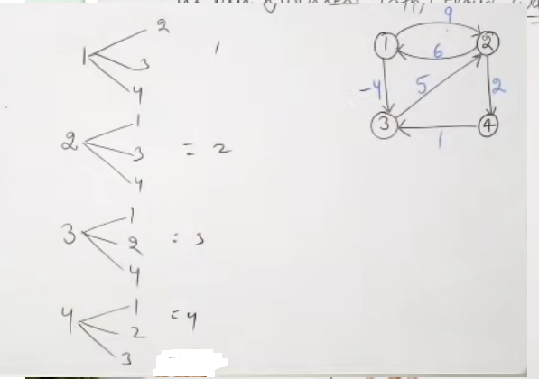

Step1

